**High-Resolution Mapping of ‘Reactive’ Inorganic Mercury Across the San Francisco Bay-Delta**

Lead PI: M. Marvin-DiPasquale (ESPD, Menlo Park, CA), [mmarvin@usgs.gov](mailto:mmarvin@usgs.gov), ph: 650-906-2640

Co-PIs: C. Alpers, J. Fleck, B. Bergamaschi (CA-WSC, Sacramento, CA), L. Windham-Myers (ESPD, Menlo Park, CA).

**Proposed work:** This study would examine for the first time the temporal (within a tidal cycle) and spatial variability of a unique fraction of the water column suspended particulate mercury (Hg) pool that is potentially available for microbial Hg-methylation (conversion to toxic methylmercury (MeHg)). This effort would leverage the existing sampling framework of a newly funded ($1.7M, $1.2 M to USGS) high-profile study to extensively map both total mercury (THg) and MeHg in the SFB-Delta (Hestir and others, 2018). See ‘Supplemental Attachment’ for further context regarding this larger, multi-year effort.

Reactive mercury (RHg) is a methodologically defined (tin reducible) subset of the larger divalent inorganic mercury (Hg(II)) pool that has been extensively studied by the Menlo Park USGS research team, primarily in surficial sediment (Marvin-DiPasquale and Cox, 2007; Marvin-DiPasquale and others, 2009a; Marvin-DiPasquale and others, 2009b; Marvin-DiPasquale and others, 2011; Marvin-DiPasquale and others, 2014) (Fig. 1). RHg represents a comparatively labile, microbially available, Hg(II) fraction that is largely associated with sorption to inorganic and organic particulate surfaces, as opposed to being part of the structural composition of particulates (e.g. mineral HgS particulates). It has been successfully used to better understand where and when microbial MeHg formation occurs and the mechanisms that control it. RHg measurement has only rarely been made on water-column particulates (Fig. 2), which represent the transport pathway of Hg(II) to the benthos where most MeHg production occurs. In addition to RHg itself, we propose to also collect samples for particulate organic carbon (POC) and nitrogen (PN), with the hypothesis that suspended particulate composition will be primary determinant of the RHg absolute and relative (as % of THg) concentration, both temporally (within a tidal cycle) and spatially in the SFB-Delta. The larger externally funded project was not able to afford these additional RHg, POC and PN measurements. Thus, this USGS funding will allow us to explore the value of these metrics in the context of the first (July 2019) of four planned sampling events.

**Products:** The near-term product (by the end of FY19) associated with this effort will be a USGS Data Release (ScienceBase) of the RHg and POC/PN data collected. Because the ultimate purpose and value of this supplemental data is in the context of the larger study, the results will ultimately be incorporated into the interpretative products associated with the larger project (ending March 2022), which include a final (publicly available) report to the primary funding agency, planned journal articles, and multiple public presentation at regional and national meetings over the course of the study.

**Affirmation:** It is understood that award funds will need to be expended within FY ’19, all products will be completed by the end of FY ’19, no additional PES funds are assumed, and funds awarded cannot carried be carried over to FY’20.

**Funding Request**: $21,265 Total Gross (assumes 19% on net for appropriated funds). Includes a $2,535 sub-allocation to the CA-WSC for sample collection and initial processing (filtering), $12,674 for approx. 70 sample analyses for both RHg and POC/PN (ESPD, Menlo Park), and $6,057 for Data Management and Science Base Product (PLB staff, Menlo Park, CA).

**REFERENCES**

Hestir, E., Marvin-DiPasquale, M., Alpers, C.N., Fleck, J.A., Windham-Myers, L., and Bergamaschi, B., 2018, High-Resolution Temporal and Spatial Mapping of Mercury in Surface Waters of the San Francisco Bay Delta. Proposal to the California Dept. Fish and Wildlife (Proposition 1 – Watershed and Delta Ecosystem Restoration Grant Programs). Submitted 06/13/2018.

Marvin-DiPasquale, M., Agee, J.L., Kakouros, E., Kieu, L.H., Fleck, J.A., and Alpers, C.N., 2011, The effects of sediment and mercury mobilization in the South Yuba River and Humbug Creek confluence area, Nevada County, California: Concentrations, speciation and environmental fate—Part 2: Laboratory Experiments: U.S. Geological Survey Open-File Report 2010−1325B, 53 p.

Marvin-DiPasquale, M., Alpers, C.N., and Fleck, J.A., 2009a, Mercury, Methylmercury, and Other Constituents in Sediment and Water from Seasonal and Permanent Wetlands in the Cache Creek Settling Basin and Yolo Bypass, Yolo County, California, 2005−06: U.S. Geological Survey Open File Report 2009-1182, 69 p.

Marvin-DiPasquale, M., and Cox, M.H., 2007, Legacy Mercury in Alviso Slough, South San Francisco Bay, California: Concentration, Speciation and Mobility U.S. Geological Survey Open-File Report number 2007-1240, 98 p.

Marvin-DiPasquale, M., Lutz, M.A., Brigham, M.E., Krabbenhoft, D.P., Aiken, G.R., Orem, W.H., and Hall, B.D., 2009b, Mercury Cycling in Stream Ecosystems. 2. Benthic Methylmercury Production and Bed Sediment−Pore Water Partitioning: Environmental science & technology, v. 43, no. 8, p. 2726-2732.

Marvin-DiPasquale, M., Windham-Myers, L., Agee, J.L., Kakouros, E., Kieu, L.H., Fleck, J., Alpers, C.N., and Stricker, C., 2014, Methylmercury production in sediment from agricultural and non-agricultural wetlands in the Yolo Bypass, California: Science of The Total Environment, v. 484, p. 288-299.



**Figure 1.** Sediment reactive mercury (RHg) concentrations as a function of salinity (left) and various regions of the San Francisco Bay estuary, delta and watershed (right). The bars represent modeled least square means (LSM) and the error bars represent standard errors. The letters above each bar represent the Tukey pair-wise comparison ranking. Bars sharing the same letters are not significantly different. The number of observations (N) used in the LSM models are indicated in each case. Unpublished data (Marvin-DiPasquale, USGS, Menlo Park, CA).

The above statistical analysis of RHg data was conducted across a very wide spatial scale, and includes sites ranging from the Sierra Nevada (watershed draining to the Delta) to the South SFB Salt Ponds. There are very clear geochemical trends, with sediment RHg concentrations decreasing with increasing salinity (Fig. 1, left). There are also very clear regional trends, with sediment from the lower Sacramento River region having the highest RHg concentration (Fig. 1, right), compared to the central SFB-Delta, the Sierra Nevada rivers/reservoirs, and other regions in the estuary downstream of the delta. Given the above trends derived across very broad regional scales and salinities, it would be very informative to better understand, at a much more targeted scale, how salinity and sub-regions within the tidally influenced mixing zones of the Lower Sacramento and central SFB-Delta affect RHg associated with surface-water particulates. Both of these regions are part of the larger externally funded study that this USGS-PES funding would be leveraging.

**Figure 2.** Percentage of particulate reactive mercury (%.p.RHg) in surface water of Alviso Slough (South San Francisco Bay) collected over 25 hours (2 tidal cycles, Feb. 7-8, 2013) and plotted with tidal stage. It is clear from this example that the %.p.RHg is not constant and can be strongly influenced by the source of the flood (bay) and ebb (watershed) tide waters.

**Supplemental Attachment**

**Excerpt from Proposition 1 Proposal (Hestir et al., 2019)**

**Optical and Mercury Specific Relationships in Delta Surface Water**

This supplemental attachment provides a brief description of, and context for, the key predictive relationships that we plan to develop from this effort. There are three general categories of relationships to be developed:

1. The first category of relationships relates optical properties of surface-water constituents and the concentrations of those constituents. This builds on ongoing efforts currently being conducted in the Delta by a multi-agency working group that includes UCM, USGS, NASA, DWR, MWD, and two of the current proposals team members (B. Bergamaschi and E. Hestir). We will focus on three specific water-column constituents that can be assessed both analytically and optically. First, dissolved organic carbon (DOC), and more generally dissolved organic matter (DOM), has a large number of commonly measured optical properties (e.g. specific UV absorption at 254 nm, multi-wavelength excitation-emission matrix spectra (EEMS)) (Downing et al. 2009, Hansen et al. 2016, Hestir et al. 2015b). Second, the physical measurements of total suspended solids (TSS) and suspended sediment concentration (SSC) have a surrogate measure as optical turbidity (Merten et al. 2014). Third, optical excitation/emission probes have been developed for the measurement of chlorophyll (Chla) and blue-green algae (Bowling et al. 2016). Laboratory analysis of DOC, TSS, and Chla concentrations, along with their respective optical properties, will be measured on all water samples (n=376) collected in the proposed work. These data will be used to establish non-Hg optical relationships across the wide range of water-quality concentration gradients that are anticipated to be encountered.
2. The second category of relationships are those between the remote-sensing (RS) water-leaving reflectance and the in-water optical measurements. This includes relating water optical measurements to water-leaving RS reflectance collected just above the surface using hand-held and ship-deployed high spectral resolution point-based spectrometers, and satellite-based RS reflectance imagery. This also builds on the above-mentioned ongoing efforts currently being conducted in the Delta by the same multi-agency working group described above. The suite of algorithms developed will incorporate atmospheric correction using the infrared bands as described in (Vanhellemont & Ruddick 2015) and with products generated using either the regionally tuned Quasi-Analytical Algorithm (QAA) (Lee et al. 2002), or semi-analytical retrievals for turbid water (Lymburner et al. 2016, Vanhellemont and Ruddick 2014).
3. The third general category of relationships are those between Hg and non-Hg constituents. The four specific Hg species on which we will focus are: particulate total mercury (p.THg), particulate methylmercury (p.MeHg), dissolved or filter-passing total mercury (f.THg), and filter-passing methylmercury (f.MeHg). In developing these relationships, both the primary analytical concentration data and the associated optical proxy data for the non-Hg constituents will be explored. We will focus on four primary Hg versus non-Hg relationships:
4. f.MeHg vs. DOC (and DOM optical properties)
5. p.MeHg vs. TSS (and optical turbidity)
6. f.THg vs. DOM (and DOM optical properties)
7. p.THg vs. TSS (and optical turbidity)

In addition to the above four Hg metrics, a number of other Hg metrics can be calculated and could be examined with respect to the three non-Hg metrics (DOC, TSS, and Chla). These include: percent filter passing methylmercury (%f.MeHg), percent particulate methylmercury (%p.MeHg), and the aqueous/solid phase partitioning coefficients (Kd) for both total mercury (Kd[THg]) and methylmercury (Kd[MeHg]).

**Hg Relationships with Dissolved Organic Carbon**

Because MeHg enters the base of the aquatic food web through the active and passive uptake from water (dissolved phase) into phytoplankton (Mason et al. 1996, Moye et al. 2002), f.MeHg concentration in surface water of the Delta is of particular interest. Thus, of the four key Hg relationships above, the most important may be that between f.MeHg and DOC (and associated DOM optical properties). This relationship was used to develop the first and only high-resolution spatial image of surface water f.MeHg concentration from airborne RS imagery in a previous study conducted in Suisun Marsh / Grizzly Bay (Fichot et al. 2016), which included a number of co-authors on the current proposal (**Figs. 1 and 2**).



**Figure 1.** The relationship between filter-passing MeHg and DOC in surface water from Suisun Marsh / Grizzly Bay (April 2014). This relationship was used in combination with optical measurements taken with the PRISM remote-sensing instrument mounted in a manned aircraft platform to derive the f.MeHg map of the study region, as shown in **Fig. 2**. Previously published in Fichot et al. (2016).



**Figure 2.** High resolution image of filter-passing MeHg concentrations in Suisun Marsh / Grizzly Bay (April 2014) as derived from the surface water f.MeHg versus DOC concentration data shown in **Fig. 1** and the RS-based (PRISM) optical measurement of colorimetric dissolved organic matter (cDOM at 440 nm). Previously published in Fichot et al. 2016.

The above example was an important first step in high-resolution Hg mapping, but was limited to a one-time sampling event in a moderately-sized regional area. The large spatial and temporal variability of the whole Delta region will certainly prove far more challenging in terms of developing predictive Hg vs. non-Hg relationships. Field data associated with traditional sampling efforts often show a wide range of variability, even if an overall trend is apparent. An example of this is shown below (**Fig. 3**) for dissolved MeHg and DOC, which represents 355 observations from numerous sampling sites throughout the Delta, collected over a wide range of specific sites and habitat types (wetlands and open-water) and temporal (seasonal and tidal) conditions. Although there is a clear positive non-linear relationship between these two variables, the variability increases as the DOC content increases (R2 = 0.62). However, when the data are limited to open-water Delta sites only (**Fig. 4**, n=121), as will be the case in the currently proposed study, the predictability of the f.MeHg versus DOC relationship increases substantially (R2 = 0.84). Further, the relationship between f.MeHg and A254 (optical absorbance at 254 nm; a qualitative and quantitative DOC proxy), the same open-water data set shows an even stronger relationship that is linear (R2 = 0.89, **Fig 5**). This example demonstrates the strong potential for optical measurements to provide high-quality predictive data for f.MeHg over multiple locations, seasons, and tidal conditions.

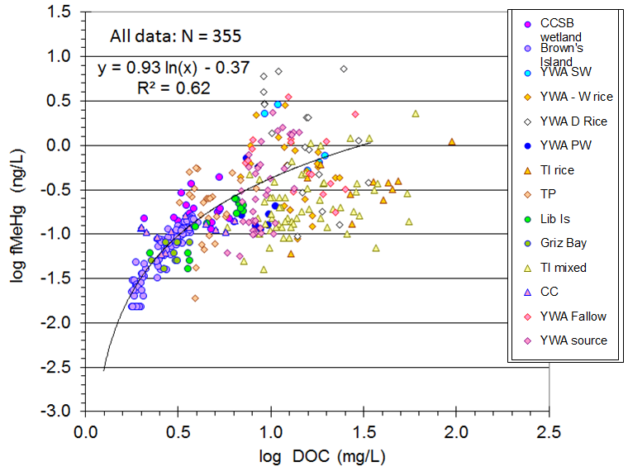**Figure 3.** LOG-LOG plot of filter-passing MeHg vs. DOC for 14 sampling locations throughout the Delta during the period April 2005 - June 2011. These data were collected over many different sampling events, habitat types, seasons, and tidal conditions. Unpublished Data, J. Fleck (USGS, Sacramento, CA).

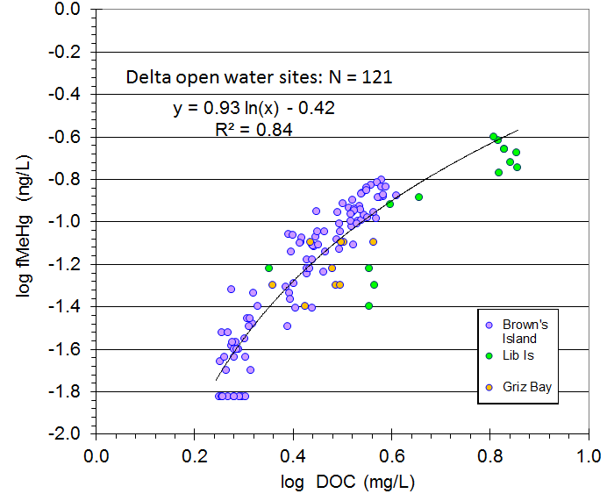**Figure 4.** LOG-LOG plot of filter-passing MeHg vs. DOC for 3 open-water (only) sampling locations (Brown’s Island, Liberty Island, and Grizzly Bay) within the Delta, collected during April 2005 - June 2011 (subset of **Fig. 3**). These data come from multiple sampling events, seasons, and tidal conditions. Unpublished Data, J. Fleck (USGS, Sacramento, CA).

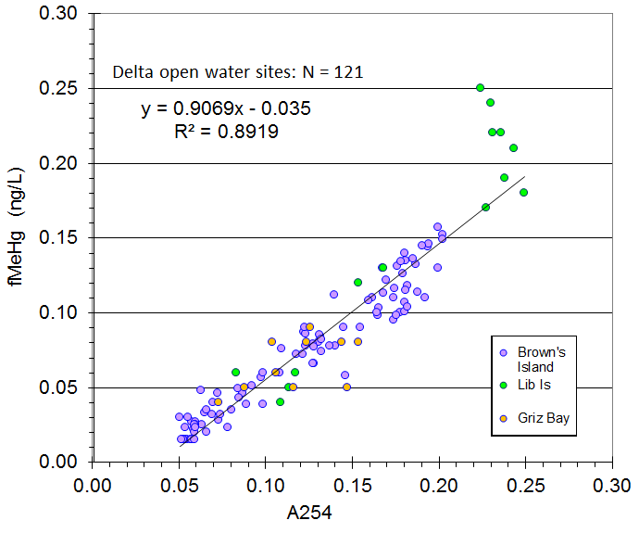**Figure 5.** X-Y plot of filter-passing MeHg vs. optical absorbance at 254 nm (A254) for 3 open-water (only) sampling locations (Brown’s Island, Liberty Island, and Grizzly Bay) within the Delta collected during April 2005 - June 2011 (subset of **Fig. 3**). These data come from multiple sampling events, seasons, and tidal conditions. Unpublished Data, J. Fleck (USGS, Sacramento, CA).

While much of the concern about the ecological impacts of Hg is focused on dissolved MeHg, total Hg (THg) is also of general concern, and exhibits a reasonably strong positive linear relationship with DOC across multiple sites, seasons, and tidal cycles (e.g., **Fig.6**).

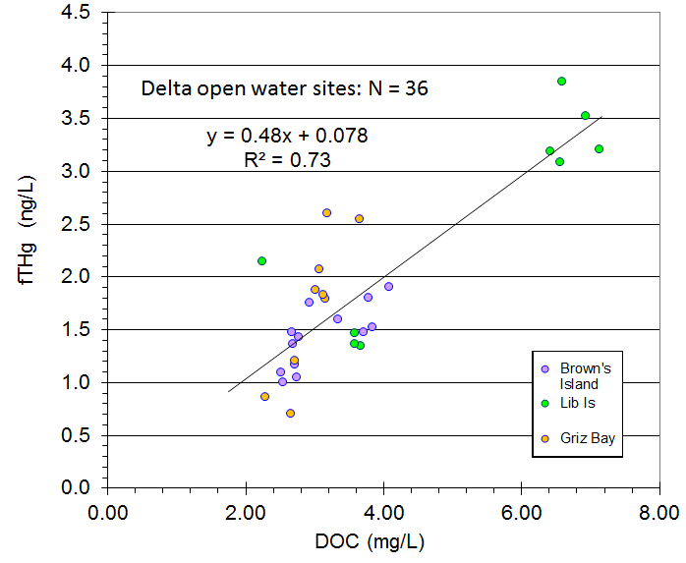 **Figure 6.** X-Y plot of filter-passing total mercury (f.THg) vs. dissolved organic carbon (DOC) for 3 open-water (only) sampling locations (Brown’s Island, Liberty Island, and Grizzly Bay) within the Delta, collected during April 2005 - June 2011. These data come from multiple sampling events, seasons, and tidal conditions. Unpublished Data, J. Fleck (USGS, Sacramento, CA).

**Hg Relationships with Particulates**

Because much of the mercury transported into the Delta exists in the particulate form (Domagalski 2001), high spatial resolution data associated with particulate Hg are needed to develop a more comprehensive understanding of the Hg transport in the system. For the base of the food web, MeHg concentration on a mass basis (i.e. ng/g dry wt of total particulates) may be more important than on a volumetric basis (ng/L), particularly at the level of primary consumers (e.g. zooplankton). The relationship between TSS and both p.MeHg and p.THg is particularly useful in this regard, and these relationships can be quite robust and stable. For example, **Fig. 7** shows the results from an 8-year Hg monitoring study in South San Francisco Bay. **Fig. 7** shows that the lowest TSS concentrations (more quiescent conditions) have the highest gravimetric p.THg and p.MeHg concentrations in this region. This case also highlights a situation in which discrete samples were collected from one location or area (upper and lower Alviso Slough in this case) over many dates (always within 2 hours of daytime high tide) to establish a useful predictive relationship for particulate Hg species based on TSS.

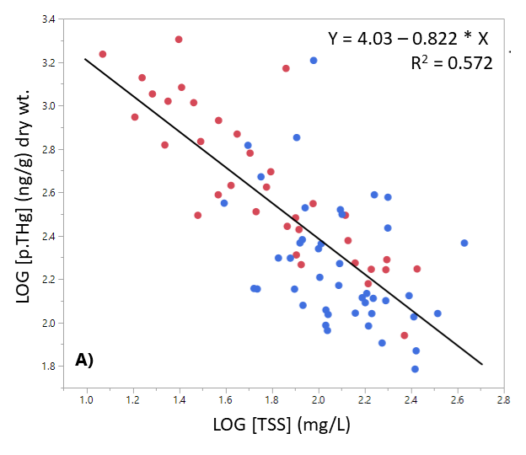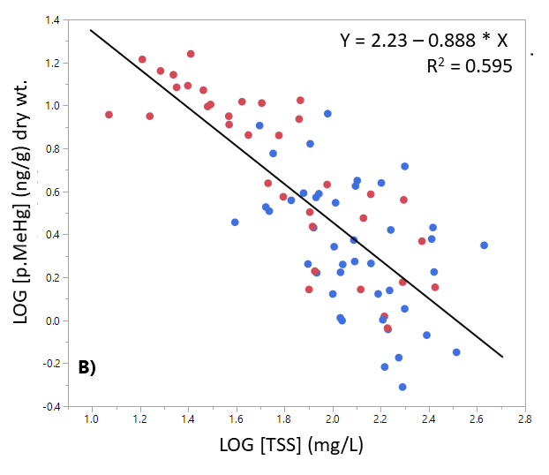

**Figure 7.** LOG-LOG plot of the relationship between surface-water A) gravimetric particulate THg (p.THg) and total suspended solids (TSS) and B) gravimetric particulate methylmercury (p.MeHg) and TSS, in upper (red symbols) and lower (blue symbols) Alviso Slough (South San Francisco Bay, CA). Samples were collected on 38 dates between April 2010 and February 2018, with the collection time always targeted during ebb tide (within 2 hrs of daytime high tide). Unpublished data: M. Marvin-DiPasquale (USGS, Menlo Park CA).

Another example of the type of data generated at a fixed location, but at a higher sampling frequency, is shown in **Fig. 8**. In this case, samples were collected every hour for a 24-hour period (two full tidal cycles) during five different sampling events. Sampling events were conducted seasonally (May 2012 - February 2013) and during the 1st flush event (December 2012). With the exception of summer (JUL 2012), the results demonstrate a good relationship between particulate MeHg (on a volumetric basis) and TSS throughout each 24-hour cycle (regardless of tidal stage). The XY relationship was similar among 4 of the 5 events (similar slope), despite the range in TSS among the five periods. This example is illustrative of the fact that the relationship between the volumetric concentration of p.MeHg and water column particulates (TSS) over the timescale of tidal cycles may also have a seasonal component, with tight relationships during most of the year and a less robust relationships during others (e.g. summer). Statistically resolving these temporal components at both scales simultaneously, using a multivariate modeling approach, is an expressed goal of this project.

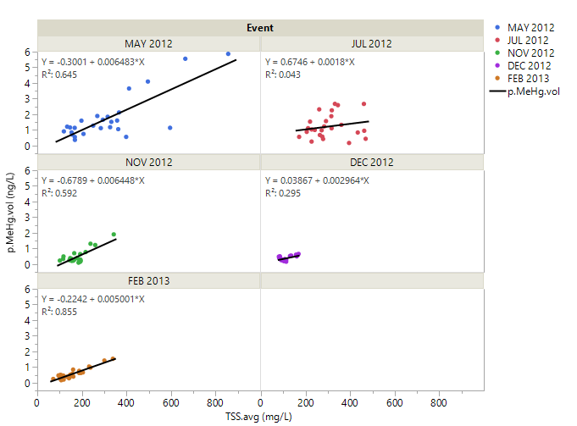

**Figure 8.** Multi-panel plot of the relationship between volumetric particulate methylmercury (p.MeHg.vol) and total suspended solids (TSS), by sampling event. Each event was 24 hours in duration (two tidal cycles) with a single sample collected every hour from a fixed site (ALSL-3) in Alviso Slough (South San Francisco Bay, CA). Unpublished data: M. Marvin-DiPasquale (USGS, Menlo Park CA).

**Relationships with chlorophyll**

Although we expect relationships between the four main Hg species of interest and chlorophyll to be weaker than the four key relationships we have identified above, we will conduct a cursory assessment of Hg and Chla relationships as well. However, regardless of how robust these Hg vs Chla relationships are, we will be able to create high-resolution spatial maps (from the transect data) and site-specific high-resolution temporal plots (from fixed monitoring data) of Chla, based on the relationships between in-situ optical properties and lab-based measurements. The RS imagery-based mapping of algal pigments (Chla) in the Delta is already an active area of research being undertaken by investigators E. Hestir and B. Bergamaschi as part of the above-mentioned multiagency project. This Chla specific data will be of extremely high value in understanding Hg processes in the Delta overall, as ecosystem variations in primary production can be a key driver and Hg biogeochemistry (Luengen and Flegal 2009). Particulate Chla can be indicative of both autochthonous (internal primary production) or allochthonous (terrestrial) sources of primary production. As such, this metric reflects an important organic component of the suspended particulate material in the water column, as the autotrophic base of the food web, the initial point of transfer of MeHg into the food web, and as potentially important surfaces on which water column MeHg production may take place (Gascón Díez et. al. 2016).

**Optical data as proxies for high resolution Hg monitoring**

Although the ambitious end goal of this project is to develop Delta-wide Hg and MeHg maps derived from remote-sensing images, the in-situ data acquired from the fixed monitoring locations and boat transects themselves will represent a major step forward in the quality and richness of Hg species data for the Delta. For each of the four fixed sites, we will be able to develop high-frequency time-series THg and MeHg plots based on the continuous monitoring sensors at each site. For each of the 15 planned spatial transects, we will be able to develop high-resolution spatial images along the transect routes, based on the boat-mounted optical sensors. Both of these approaches will yield powerful data sets that provide a more detailed and holistic view of Hg dynamics in this complex system that currently exists. An example of high spatial resolution transect data is given in **Figure 9**, which shows fluorescent dissolved organic matter (FDOM) concentrations mapped in a single day via in-situ optical sensors mounted to a boat. This image shows lower FDOM concentrations (blue) in the north and southeast Delta compared to the central and western Delta (red). With the development of a spatio-temporal predictive model for Hg and MeHg from optical data, a map such as this depicting Hg species concentration as measured during a given boat transect could be created.

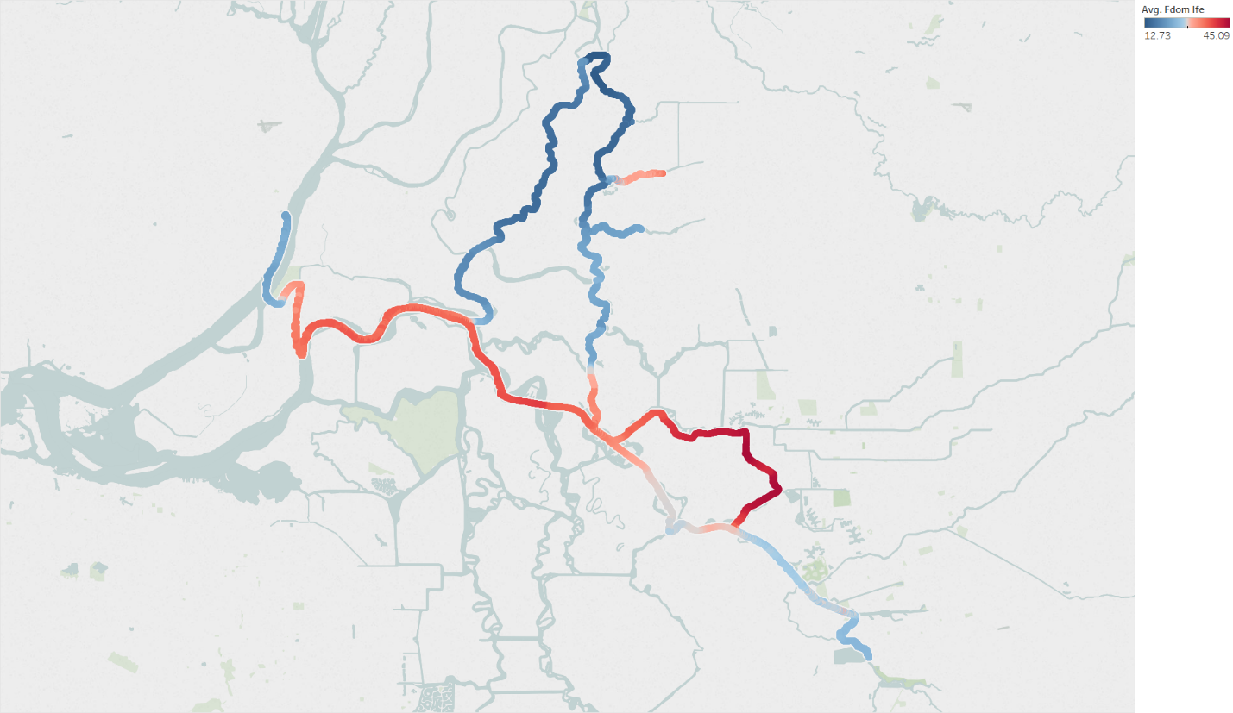

**Figure 9.** Map of the Sacramento – San Joaquin Delta showing fluorescent dissolved organic matter (FDOM) concentrations along a single boat transect conducted over an 8-hour period on May 16, 2018, as measured via an under way data collection system (Downing et al., 2016). Unpublished Data: B. Bergamaschi (USGS, Sacramento, CA).

**Addressing Variability and System Complexity**

Results from previous studies lead us to hypothesize that Hg and non-Hg constituents co-vary significantly enough in the Delta for us to develop predictive models of Hg species from in-situ optical data (and potentially RS). However, it is evident that there is high spatial and temporal variability in the covariation between Hg and non-Hg constituents that precludes a simple, one-size-fits-all X-Y relationship robust enough to estimate specific Hg fractions across the Delta under all conditions. The sampling design of this study is intended to explicitly close this gap by combining both fixed station and transect sampling, coupled with high-resolution optical monitoring (both fixed station and via boat). This design will enable us to statistically resolve the temporal and spatial components embedded within the resulting data set. The first step in this process involves developing the explicit relationships along the spatial gradient for individual sampling events (following **Fig. 1)** and the relationships for individual fixed locations around the bay periphery sampled over two time scales (seasonal to hourly) (following **Figs. 7 and 8**). This is followed by an assessment of variability of the field data within and among sampling events in both dimensions (space and time). The final step in the data analysis involves the development multi-variate geostatistical models that not only include the traditional X (e.g. TSS) and Y (e.g. p.MeHg) variables, but will also include explicit accounting for time (e.g. tidal stage, season) and space, thus enabling Hg estimates across the Delta. By building on existing data from the Delta (unpublished USGS data (**Figs. 3-6)** and existing RMP Hg data) along with the new data collected by the proposed sampling design, we will for the first time have enough data sufficiency to achieve this modeling objective. Ultimately, we are providing the temporally and spatially resolved predictive framework and the initial high-resolution data that can continue to improve in accuracy as new data of the same type becomes available in the future.

See SA-1 (original Proposal) for full reference list